COMP 3270 Assignment 4 (100 points)
Due by 11:59PM on Tuesday, April 25th, 2023
Instructions:
- Late submissions will not be accepted unless prior permission has been granted or there is a valid and verifiable excuse.
- Think carefully; formulate your answers, and then write them out concisely using English, logic, mathematics and pseudocode (no programming language syntax).
- Type your final answers in this Word document.
- Don’t turn in handwritten answers with scribbling, cross-outs, erasures, etc. If an answer is unreadable, it will earn zero points. Neatly and cleanly handwritten submissions are acceptable.
1. (10 points) Show d and π values that result from running Breadth First Search on the directed graph below using vertex 3 as the start node.
π = NIL
d= $∞$
d= 3
π = 4
d= 0
3
2
1
π = NIL

d= 1
6
5
4
π = 3
π = 5
d= 2
d= 1
π = 3

2. (10 points) Show how Depth First Search works on the graph below by marking on the graph the discovery and finishing times (d and f) for each vertex and the classification of each edge. Assume that the for loops in DFS and DFS-VISIT consider vertices alphabetically.
d = 17
f = 20
d = 1
f = 16
d = 2
f = 7
r
q
s
d = 3
f = 6
t
d = 8
f = 15
y
d = 18
f = 19
u
w
v
d = 13
f = 14
d = 4
f = 5
d = 9
f = 12
x

d = 10
f = 11
z

3. (15 points) List the vertices of the graph below in Topological Order, as produced by the Topological Sort algorithm. Assume that the for loops in DFS and DFS-VISIT consider vertices alphabetically.

p
o
n
m
r
q
u
t
z
y
x
w

s

v

p, n, o, s, m, r, y, v, x, w, z, u, q, t

4. (15 points) Do Problem 24.1-1 (p. 654) (you do not have to do the last part, i.e., running the algorithm again after changing an edge weight).

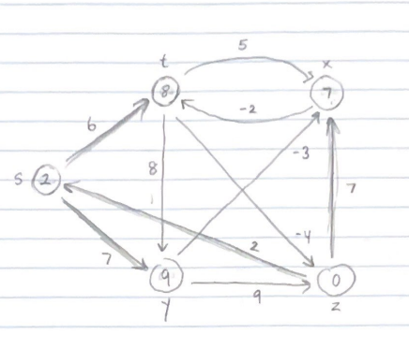

1st Pass
z.d = 0, z.$π$ = NIL
y.d = 9, y.$π$ = s
x.d = 7, x.$π$ = z
s.d = 2, s.$π$ = z
t.d = 8, t.$π$ = s

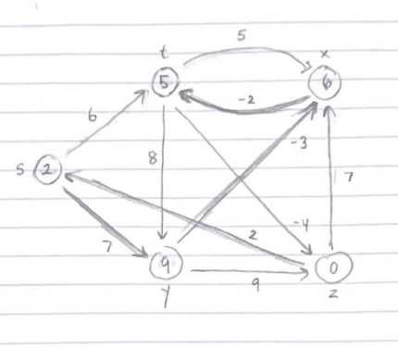

2nd Pass
z.d = 0, z.$π$ = NIL
y.d = 9, y.$π$ = s
x.d = 6, x.$π$ = y
s.d = 2, s.$π$ = z
t.d = 5, t.$π$ = x

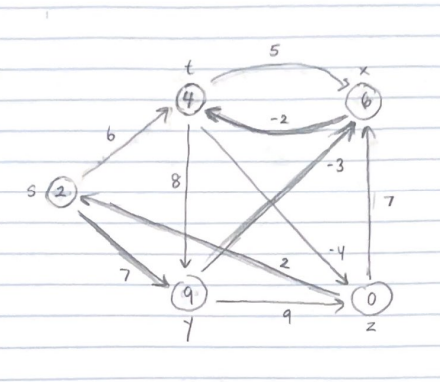

3rd Pass
z.d = 0, z.$π$ = NIL
y.d = 9, y.$π$ = s
x.d = 6, x.$π$ = y
s.d = 2, s.$π$ = z
t.d = 4, t.$π$ = x


4th Pass
z.d = 0, z.$π$ = NIL
y.d = 9, y.$π$ = s
x.d = 6, x.$π$ = y
s.d = 2, s.$π$ = z
t.d = 4, t.$π$ = x

5. (15 points) Do Problem 24.2-1 (p. 657 of the text). Show the results similar to Fig. 24.5.
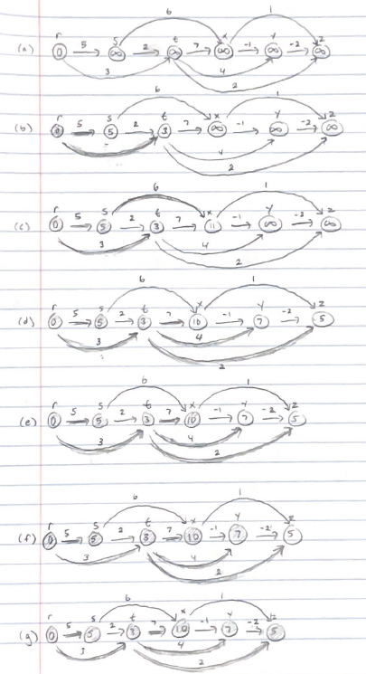

r.d = 0, r.$π$ = NIL
s.d = 5, s.$π$ = r
t.d = 3, t.$π$ = r
x.d = 10, x.$π$ = t
y.d = 7, y.$π$ = t
z.d = 5, z.$π$ = t

6. (15 points) Do Problem 24.3-1 (p. 662 of the text).

s as the source vertex

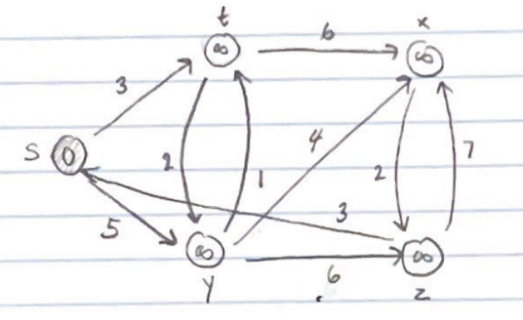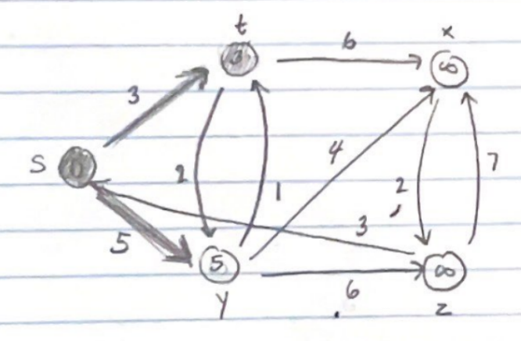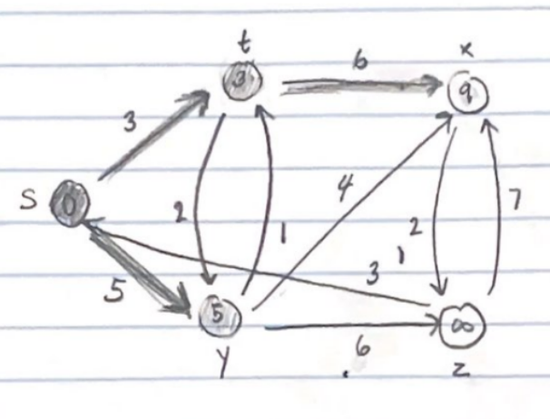

S = {} S = {s} S = {s, t}

s.d = 0, s.$π$ = NIL s.d = 0, s.$π$ = NIL s.d = 0, s.$π$ = NIL
t.d = $∞$, t.$π$ = NIL t.d = 3, t.$π$ = s t.d = 3, t.$π$ = s
y.d = $∞$, y.$π$ = NIL y.d = 5, y.$π$ = s y.d = 5, y.$π$ = s
x.d = $∞$, x.$π$ = NIL x.d = $∞$, x.$π$ = NIL x.d = 9, x.$π$ = t
z.d = $∞$, z.$π$ = NIL z.d = $∞$, z.$π$ = NIL z.d = $∞$, z.$π$ = NIL

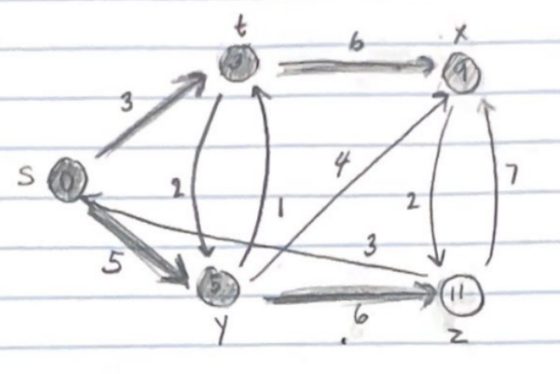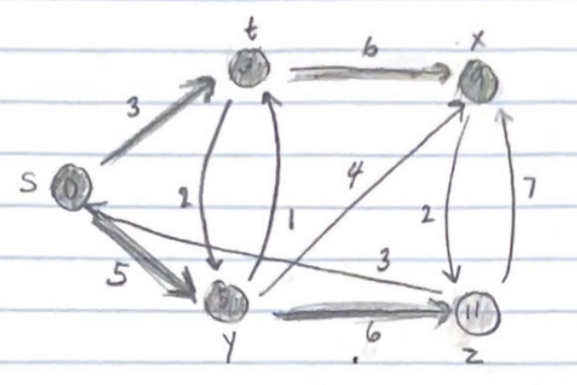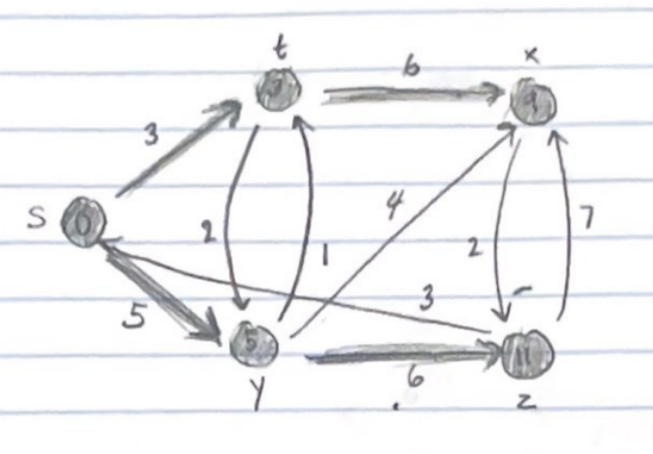
S = {s, t, y} S = {s, t, y, x} S = {s, t, y, x, z}

s.d = 0, s.$π$ = NIL s.d = 0, s.$π$ = NIL s.d = 0, s.$π$ = NIL
t.d = 3, t.$π$ = s t.d = 3, t.$π$ = s t.d = 3, t.$π$ = s
y.d = 5, y.$π$ = s y.d = 5, y.$π$ = s y.d = 5, y.$π$ = s
x.d = 9, x.$π$ = t x.d = 9, x.$π$ = t x.d = 9, x.$π$ = t
z.d = 11, z.$π$ = y z.d = 11, z.$π$ = y z.d = 11, z.$π$ = y

z as the source vertex

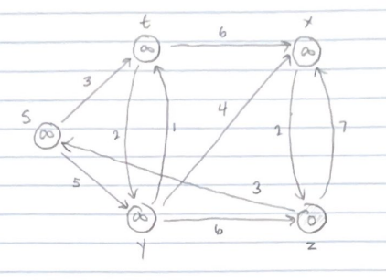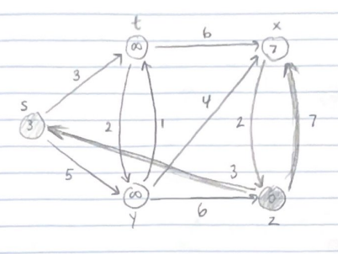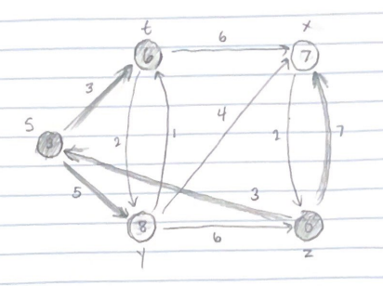

S = {} S = {z} S = {z, s}

s.d = $∞$, s.$π$ = NIL s.d = 3, s.$π$ = z s.d = 3, s.$π$ = z
t.d = $∞$, t.$π$ = NIL t.d = $∞$, t.$π$ = NIL t.d = 6, t.$π$ = s
y.d = $∞$, y.$π$ = NIL y.d = $∞$, y.$π$ = NIL y.d = 8, y.$π$ = s
x.d = $∞$, x.$π$ = NIL x.d = 7, x.$π$ = z x.d = 7, x.$π$ = z
z.d = 0, z.$π$ = NIL z.d = 0, z.$π$ = NIL z.d = 0, z.$π$ = NIL

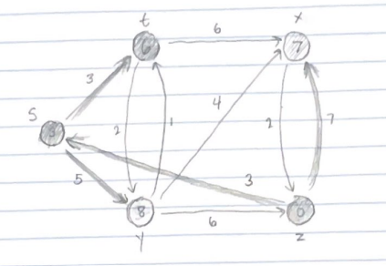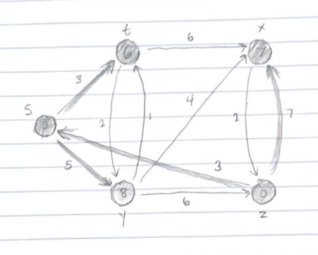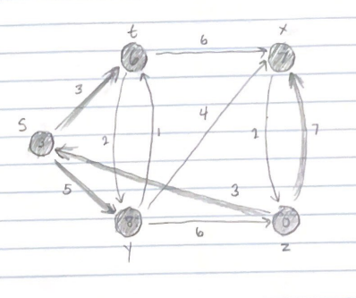

S = {z, s, t} S = {z, s, t, x} S = {z, s, t, x, y}

s.d = 3, s.$π$ = z s.d = 3, s.$π$ = z s.d = 3, s.$π$ = z
t.d = 6, t.$π$ = s t.d = 6, t.$π$ = s t.d = 6, t.$π$ = s
y.d = 8, y.$π$ = s y.d = 8, y.$π$ = s y.d = 8, y.$π$ = s
x.d = 7, x.$π$ = z x.d = 7, x.$π$ = z x.d = 7, x.$π$ = z
z.d = 0, z.$π$ = NIL z.d = 0, z.$π$ = NIL z.d = 0, z.$π$ = NIL

(7) (10 points) Suppose that a graph G has a Minimum Spanning Tree (MST) computed. How quickly can we update the MST if we add a new vertex and incident edges to G. Propose and outline a strategy and present an algorithm (you can reuse graph algorithms covered in class as building blocks as part of your solution) and evaluate its asymptotic complexity.

My strategy to update the MST if we add a new vertex and incident edges to G would be to first pick the lightest incident edge connected to the new vertex and add that edge to the minimum spanning tree. Furthermore, in the scenario where there is another edge connected to the new vertex that can be added to the MST and a previous more heavier edge can be removed we can follow the following steps. Let’s call the set of edges connected to the new vertex not including the lightest edge d. Our goal is to add each edge in d to the MST which will induce a cycle in the MST. Once we induce a cycle we should remove the heaviest edge in a cycle which will then result in successfully modifying the MST. We will perform a depth first search to traverse the edges in the MST to identify the cycles to remove the largest edge.

Let’s call the already existing MST M and the new vector u. Let’s also have a modified version of the DFS where it will break immediately when reaching back to the source vertex and it will return the edge of the largest weight in the cycle. We will iterate through the edges in our MST with this function.

ModifyMST(M, G, W, u)

minWeight = $∞$
minEdge = NIL
For each v € G.Adj[u]
if w(u, v) < minWeight
then minWeight = w(u, v)
minEdge = (u, v)

M = M U {minEdge}

For each v € G.Adj[u] and (u, v) is not minEdge
Y = M U {(u ,v)}
Z = ModifiedDFS(Y, u)

if (u,v) is not Z
then M = M U {(u, v)}
Remove Z from M

The asymptotic time complexity of this algorithm would be O(|V| x (|V| + |E|)) which is worse than the time complexity of both Kruskal’s and Prim’s algorithms which is O(E log V).

(8) (10 points) What is the running time of BFS if we represent its input graph by an adjacency
matrix and modify the algorithm to handle this form of input?

The running time of the BFS algorithm if we use an adjacency list is theta(|V| + |E|). However, if the graph is a complete graph the algorithm’s running time would be O(|V| + |V|^2). It would be this running time because in the actual breadth-first search part of the algorithm, the algorithm checks every edge for each vertice. If it’s a complete graph then there would be |V| edges for each vertice causing the algorithm to check |V|^2 edges. Which is why it would be O(|V| + |V|^2) in the worst case if it’s a complete graph. If we represent its input graph by an adjacency matrix, the running time of the BFS algorithm would be theta(|V| + |V|^2). This algorithm is theta(|V| + |V|^2) because in the breadth first search part of the algorithm, even if the graph is not a complete graph, the algorithm must iterate through every cell in the matrix. In an adjacency matrix to iterate through the edges you must always iterate |V| columns for |V| vertices even if an edge doesn’t exist and the cell value is 0. Therefore, a BFS algorithm with an adjacency matrix input would have a worse running time because in the usual case it has a running time of theta(|V| + |V|^2) compared to the usual case of adjacency list input of theta(|V| + |E|).

